Seasonal Depression
By: Tamicka Monson
Are you S.A.D.?

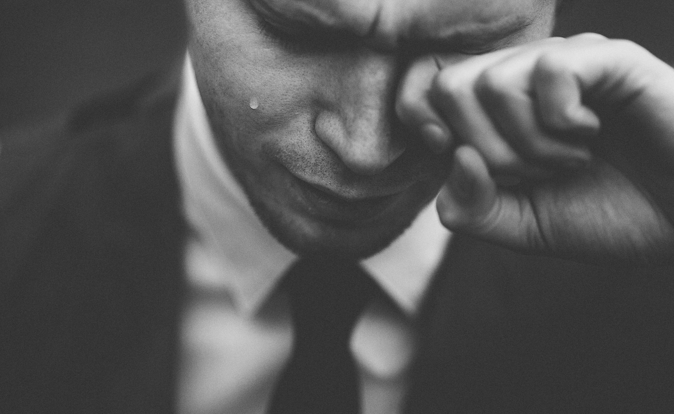

Seasonal Depression
Also known as Seasonal Affective Disorder (SAD) is a mood disorder that occurs at the same time each year, generally in the fall in winter

Causes
Unknown, though some scientists suggest brain chemicals (such as serotonin), low vitamin D, or high melatonin levels are factors

Risk Factors
- Age: Young adults at greater risk
- Being female
- Those with a family history
- Having major depression or bipolar depression
- Living far from the equator

Symptoms (persisting for at least 2 years)
- Feeling depressed most of the day, most days
- Little interest in activities once enjoyed
- Less energy
- Fatigue
- Increased desire to be alone
- Trouble with sleep and/or concentration
- Changes in appetite or weight
- Hopelessness and/or suicidal thoughts
- Feeling agitated

Treatments
Light therapy*
Medication
Vitamin D
Psychotherapy

*Check with doctor first; not recommended for some such as those with Bipolar Depression.

Sources:
Seasonal Affective Disorder. (n.d.).
https://www.nimh.nih.gov/health/topics/seasonal-affective-disorder/index.shtml.

Goldberg, J. (2018, April 13). Seasonal depression (Seasonal affective disorder) symptoms, causes, treatments.
https://www.webmd.com/depression/guide/seasonal-affective-disorder#1.

