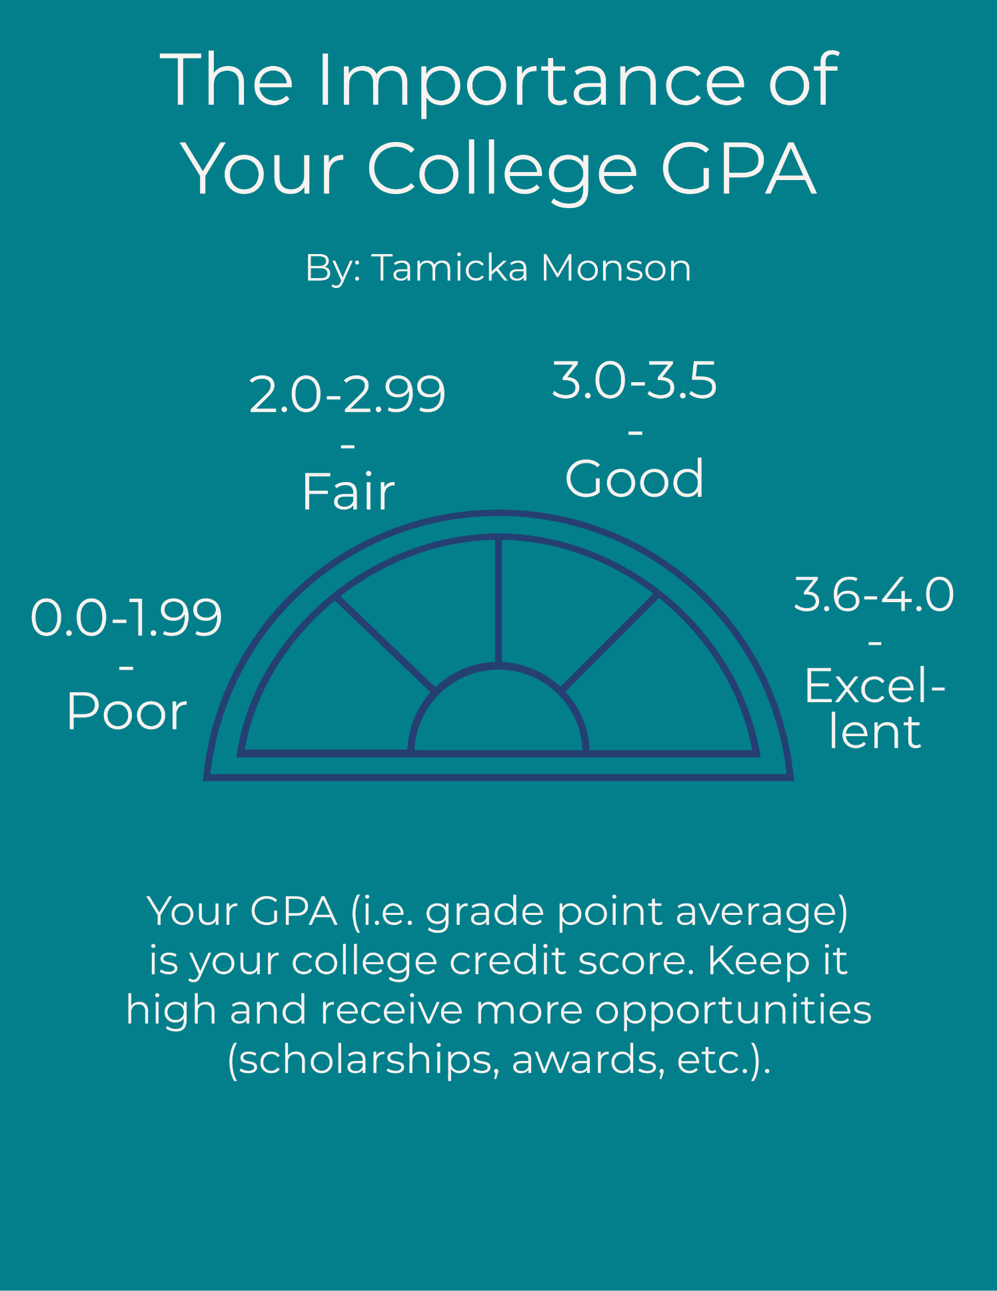

Ways to improve or preserve your GPA:

- Before you enroll:
  - Take an aptitude test and personality test to see what career fields and roles would be best for you. You can find them at your school or online (avoid the bad ones). These can save you time and energy to avoid choosing a major that doesn’t well fit your academic ability. Even if your tests indicate fields that may be undesirable to others or stigmatized, you will save yourself a lot of frustration by going with your natural talents, interests, and abilities. (Note: In certain cultures, choosing a major based on your aptitude is not always possible due to cultural or familial expectations. If that is the case for you, seek support. The following steps 2-12 can help.)
  - Try not to compare yourself to others.
  - See what your options are. Do you need to attend college for your chosen field? If not, consider other options such as trade school, internship, etc.
  - If finances are an issue,
    - Consider attending a community college for the first two years. You will save money.
    - Apply for scholarships and grants, which can help you to reduce your workload and help you adequately focus on your studies.
    - As much as possible, avoid going into debt.
- Create a daily schedule that includes classes, work, study time, and self-care time.
- During the first week of courses, list out all your assignments on a calendar for the semester. Begin working on papers and longer-term assignments in advance. Doing these steps will help you to not wait until the last minute to complete an assignment.
- As able, make your home a peaceful place.
- Find a quiet place to study consistently.
- Seek help for emotional or mental health needs. Many colleges offer counseling services at a reduced fee.
- If you need help with mental, intellectual, or physical disabilities which could impact your studies, reach out to the appropriate office on campus (sometimes referred to as disability support). These offices can give you a list of places to get tested for learning disabilities or similar. You may be able to get financial assistance with testing from them if you qualify. Also, if your disability is impacting your grades and hindering you from financial aid, you may receive support to continue financial aid given your circumstances. Ask your disability support office for more information.
- Prioritize tasks and don’t take on more than you can manage.
- Don’t be afraid to ask for help. Seek tutoring services. While some colleges charge for tutoring, you may be able to get a fee waiver. Additionally, some local libraries offer to tutor for free at the college level. You can also talk with your classmates and teachers for help.
- Eat a balanced meal consistently. If you have trouble with getting food due to finances, visit local food pantries and/or on-campus resources.
- Set boundaries. Learn to say, “No” to excessive partying and other obstacles that get in your way.
- Get a mentor, someone who is older and wiser. Set goals for where you want to be in the next five years. Discuss the steps you will take to get there.

